Q1:
class Item{
String Title, Author;
int Year;
Item(String Title,String Author,int Year){
this.Title=Title;
this.Author=Author;
this.Year=Year;
}
@Override
public String toString() {
return "Title: "+Title+" Author: "+Author+" Year: "+Year;
}
}
class Book extends Item{
String publisher,ISBN;
Book(String Title, String Author, int Year,String publisher,String ISBN) {
super(Title, Author, Year);
this.publisher=publisher;
this.ISBN=ISBN;
}
@Override
public String toString() {
return super.toString()+" Publisher: "+publisher+" ISBN: "+ISBN;
}
}
class Magazine extends Item{
String Publisher, issueNumber;
Magazine(String Title, String Author, int Year,String Publisher,String issueNumber) {
super(Title, Author, Year);
this.Publisher=Publisher;
this.issueNumber=issueNumber;
}
@Override
public String toString() {
return super.toString()+" Publisher: "+Publisher+" Issue Number: "+issueNumber;
}
}
class DVD extends Item{
String Director,length;
DVD(String Title, String Author, int Year,String Director,String length) {
super(Title, Author, Year);
this.Director=Director;
this.length=length;
}
@Override
public String toString() {
return super.toString()+" Director: "+Director+" Length: "+length;
}
}
public class Q1 {
public static void main(String[] args) {
Book i1 = new Book("Brave","Dangling",2020,"Abs Publisher","843022203");
Magazine m1 =new Magazine("Forbes","Ching jang",2022,"Emirates","33987");
DVD d1= new DVD("50 Shades","King PAu",2016,"Khaby","45min");
System.out.println("--Book--\n");
System.out.println(i1.toString());
System.out.println("\n--Magazine--\n");
System.out.println(m1.toString());;
System.out.println("\n--DVD--\n");
System.out.println(d1.toString());
}
}
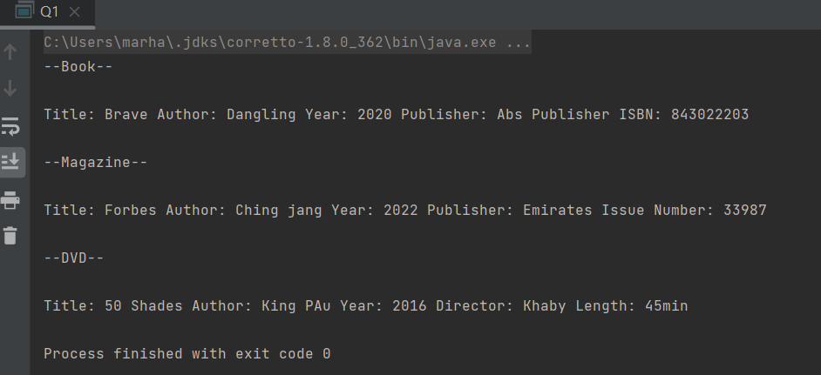
Q2:
class Person{
String name,email,phone;
Person(String name,String email,String phone){
this.name=name;
this.email=email;
this.phone=phone;
}
@Override
public String toString() {
return "Name: "+name+" Email:"+email+" Phone: "+phone;
}
}
class Student extends Person{
String StudentID,major;
private float GPA;
Student(String name, String email, String phone,String StudentID,String major,float GPA) {
super(name, email, phone);
this.StudentID=StudentID;
this.major=major;
this.GPA=GPA;
}
@Override
public String toString() {
return super.toString()+" Student ID: "+StudentID+" Major: " +major;
}
public float getGPA() {
return GPA;
}
void print(){
System.out.println("Name: " + name);
System.out.println("Email: " + email);
System.out.println("Phone: " + phone);
System.out.println("Major: " + major);
System.out.println("ID: " + StudentID);
System.out.println("GPA: " + getGPA());
}
}
class Faculty extends Person{
String facultyID,department;
private String Rank;
Faculty(String name, String email, String phone,String facultyID,String department,String Rank) {
super(name, email, phone);
this.department=department;
this.facultyID=facultyID;
this.Rank = Rank;
}
public String getRank() {
return Rank;
}
void print(){
System.out.println("Name: " + name);
System.out.println("Email: " + email);
System.out.println("Phone: " + phone);
System.out.println("department: " + department);
System.out.println("ID: " + facultyID);
System.out.println("Rank: " + getRank());
}
}
class Staff extends Person{
String StaffID, JobTitle;
private double Salary;
Staff(String name, String email, String phone,String StaffID,String JobTitle,double Salary) {
super(name, email, phone);
this.StaffID = StaffID;
this.JobTitle = JobTitle;
this.Salary = Salary;
}
public double getSalary() {
return Salary;
}
void print(){
System.out.println("Name: " + StaffID);
System.out.println("Email: " + email);
System.out.println("Phone: " + phone);
System.out.println("StaffID: " + StaffID);
System.out.println("Job: " + JobTitle);
System.out.println("Salary: " + getSalary());
}
}
public class Q2 {
public static void main(String[] args) {
Student s1 = new Student("Arham","k224080@gmail.com","98330-330-33","22k4080","Ai",2.7f);
Faculty f1 = new Faculty("Jamil","James@nu.edu.pk","023-5648-788","01k-550","Ai","Professor");
Staff stf1 = new Staff("Jabbar","jabbarprince@gmail.com","13123-3568-987","B-554","Accountant",22500.0);
System.out.println("\t---University Heirarchy---\n");
System.out.println("Student:\n");
s1.print();
System.out.println("\nFaculty;\n");
f1.print();
System.out.println("\nStaff:\n");
stf1.print();
}
}

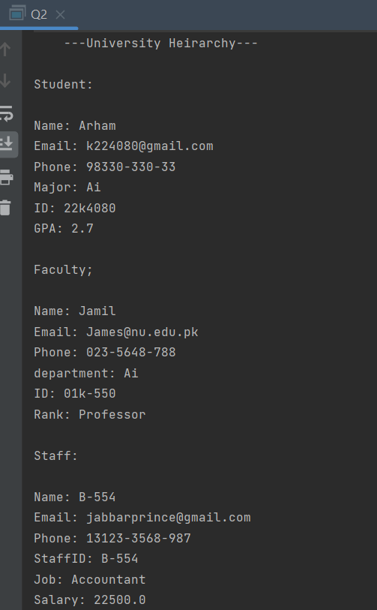

Q3:
import java.util.Scanner;
class Robot{
int x, y;
String direction;
Robot(int x,int y,String direction){
this.x=x;
this.y=y;
this.direction=direction;
}
void display(){
System.out.println("The initial position of robot: " + direction);
}
}
class MovingRobot extends Robot{
int steps;
void MoveRobot(int steps){
if (direction=="N" || direction == "n"){
y += steps;
}
if (direction == "E" || direction == "e") {
x += steps;
}
if (direction=="S" || direction == "s") {
y -= steps;
}
if (direction == "W" || direction == "w") {
x -= steps;
}
}
void Display(){
System.out.println("Updated X coordinates: " + x);
System.out.println("Updated Y Coordinates: " + y);
}
MovingRobot(int x, int y, String direction) {
super(x, y, direction);
}
}
public class Q3 {
public static void main(String[] args) {
Scanner scanner = new Scanner(System.in);
MovingRobot r1 = new MovingRobot(5,4,"W");
r1.MoveRobot(5);
r1.display();
r1.Display();
}
}

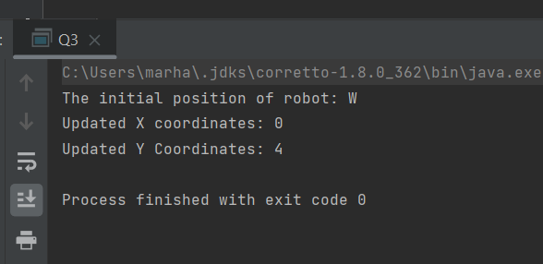
Q4:
class Accounts{
protected double Balance;
Accounts(double Balance){
this.Balance = Balance;
}
void debit(double amount){
Balance += amount;
}
void credit(double amount){
Balance -= amount;
}
public double getBalance() {
return Balance;
}
}
class savingAccount extends Accounts{
int timeSpan;
double calculateInterest(){
double interest=0,rate = 0.2;
interest += (getBalance()*rate*timeSpan);
return interest;
}
void credit(double amount1){
Balance += amount1;
}
savingAccount(double Balance,int timeSpan) {
super(Balance);
this.timeSpan = timeSpan;
}
}
class checkingAccount extends Accounts{
checkingAccount(double Balance) {
super(Balance);
}
}
public class Q4 {
public static void main(String[] args) {
double Interest;
savingAccount sA1= new savingAccount(50000.0,5);
sA1.debit(5000);
sA1.credit(sA1.calculateInterest());
System.out.println("Account Balance after 5 years of interest: " + sA1.getBalance());
}
}
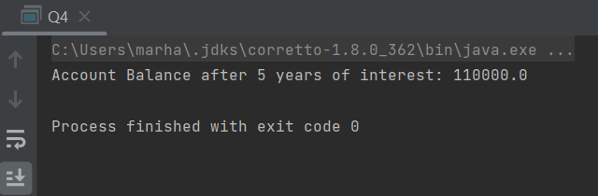
Q5:
import java.util.Arrays;
import java.util.Collections;
class Sorting{
private void descend(int[] array) {
int i = 0;
int j = array.length - 1;
while (i < j) {
int temp = array[i];
array[i] = array[j];
array[j] = temp;
i++;
j--;
}
}
private void descend(String[] array) {
int i = 0;
int j = array.length - 1;
while (i < j) {
String temp = array[i];
array[i] = array[j];
array[j] = temp;
i++;
j--;
}
}
Sorting(){}
void sort(int[] array) {
for (int i = 0; i < array.length; i++) {
for (int j = i + 1; j < array.length; j++) {
int tmp = 0;
if (array[i] > array[j]) {
tmp = array[i];
array[i] = array[j];
array[j] = tmp;
}
}
}
}
void sort(String[] array){
for (int i = 0; i < array.length; i++)
{
for (int j = i + 1; j < array.length; j++)
{
String tmp ;
if (array[i].compareTo(array[j])>0)
{
tmp = array[i];
array[i] = array[j];
array[j] = tmp;
}
}
}
}
void sort(int[] array, boolean descending){
if (descending){
Arrays.sort(array);
descend(array);
}else {
if (descending == false){
for (int i = 0; i < array.length; i++) {
for (int j = i + 1; j < array.length; j++) {
int tmp = 0;
if (array[i] > array[j]) {
tmp = array[i];
array[i] = array[j];
array[j] = tmp;
}
}
}
}
}
}
void sort(String[] array, boolean descending){
if (descending){
Arrays.sort(array);
descend(array);
} else if (descending==false) {
for (int i = 0; i < array.length; i++)
{
for (int j = i + 1; j < array.length; j++)
{
String tmp ;
if (array[i].compareTo(array[j])>0)
{
tmp = array[i];
array[i] = array[j];
array[j] = tmp;
}
}
}
}
}
}
public class Q5 {
public static void main(String[] args) {
int arr[] = { 1, 3, 5, 7, 11 };
String arr1[] = { "a", "c", "b", "d","e" };
Sorting s1 = new Sorting();
s1.sort(arr);
System.out.println("Sorted integer array: "+ Arrays.toString(arr));
s1.sort(arr1);
System.out.println("Sorted String array: "+ Arrays.toString(arr1));
s1.sort(arr,true);
System.out.println("Descending Sorted integer array: "+ Arrays.toString(arr));
s1.sort(arr1,true);
System.out.println("Descending Sorted String array: "+ Arrays.toString(arr1));
}
}

